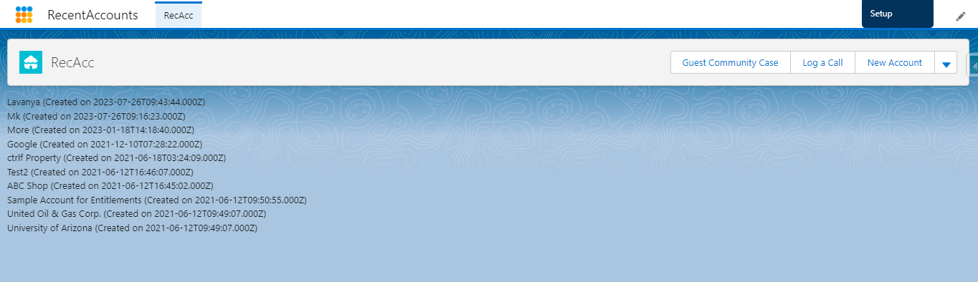

* Build a basic lightning component that can query a list of 10 most recently created accounts and display it using a lightning app.